**Introduction**

A lathe is a tool that rotates the workpiece about an axis of rotation to perform various operations such as cutting, sanding, knurling, drilling, deformation, facing, and turning, with tools that are applied to the workpiece to create an object with symmetry about that axis.

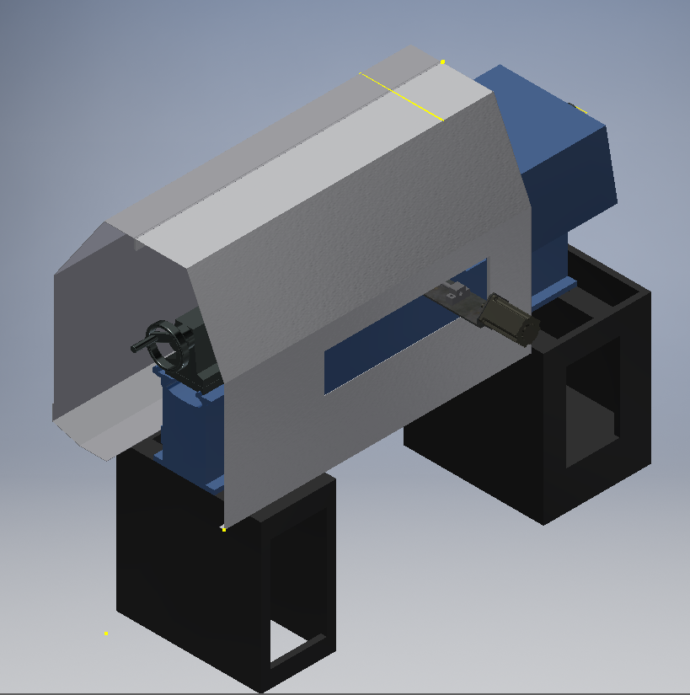

Currently we have a Lathe machine that is manually operated and this project is about shifting the operation from manually operated to automatic operation. In addition to that, new motors will be installed to move on the x-axis and z-axis to achieve this. There is also a new design for the cover of the machine to improve on the coolant proofing as well as to ensure the machine is safely operated.

**Personal Contribution**

On an individual contribution, I was paired with Joshua Kapusana to design the cover of the Lathe Machine. From the previous project, the cover was designed but not suitable for the new project. For this reason, we took measurements on the actual machine in order to make a new design of the cover.

The cover of the machine has basically 5 parts; the front and back plates, the two side plates as well as the piano hinge. All these parts were drawn separately and assembled as one cover. I and my partner Joshua worked hand in hand to put everything together.

Most of the sketching was done by Joshua and I did most of the drawing using Autodesk Inventor. The pictures below are the parts of the Lathe Machine cover.

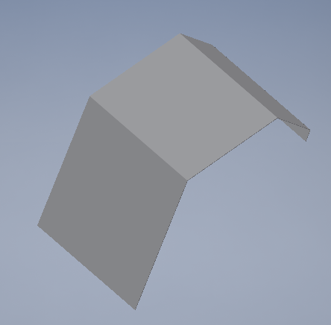 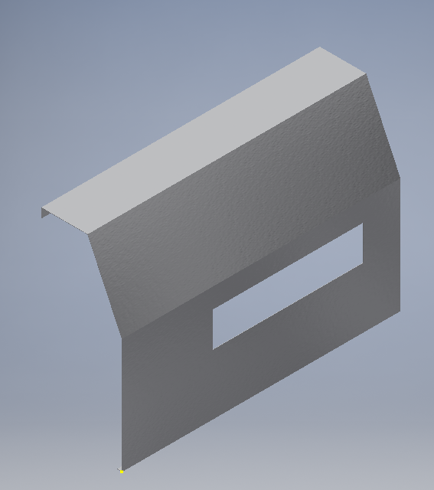

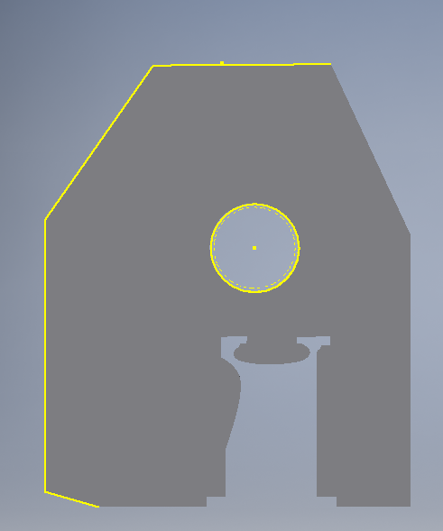 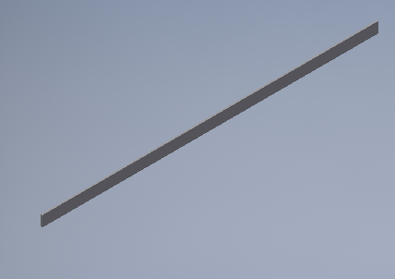

The specifications of the design are;

Length: 1200mm

Height: 811mm